**AMAHORO SENIOR SECONDARY SCHOOL**

**Uganda Certificate of Education**

**END OF TERM ONE EXAMS 2024**

**S.4 CHEMISTRY**

**Paper 1**

**Practical**

**TIME; 2 Hours**

**INSTRUCTIONS TO CANDIDATES:**

*This paper consists of* **two** *sections;* **A** *and* **B**. *It has* **six** *examination items.*

*Section* **A** *has* **two compulsory** *items*.

*Section* **B** *has* **two Parts**; **I** and **II**. *Answer* **one** *item from* **each** *part*.

*Answer four items in all.*

*Answers to Section* **A must** *be written in the spaces provided while those of Section* **B must** *be written on the answer booklet(s) provided.*

*Any additional item(s) answered will* **not** *be scored.*

**SECTION A**

***Answer* all *the items from this section***.

**Item 1.**

Onyera, living in an area where they use bore hole water, slid, fell and his white shirt became dirty. He decided to use a detergent to clean his shirt. The shirt remained with some brown spots yet he had rinsed it several times.

**Task:**

As a chemistry learner;

(a) Point out the problem Onyera made when choosing a product.

__________________________________________________________________

__________________________________________________________________

__________________________________________________________________

(b) Help Onyera understand how the product works.

__________________________________________________________________

__________________________________________________________________

__________________________________________________________________

__________________________________________________________________

__________________________________________________________________

__________________________________________________________________

__________________________________________________________________

__________________________________________________________________

__________________________________________________________________

______________________________________________________

______________________________________________________

______________________________________________________

______________________________________________________

__________________________________________________________________

(c) advice Onyera on the challenges associated with the long term use of the product.

__________________________________________________________________

__________________________________________________________________

__________________________________________________________________

__________________________________________________________________

__________________________________________________________________

__________________________________________________________________

__________________________________________________________________

__________________________________________________________________

__________________________________________________________________

**Item 2.**

Peter is in the process of constructing his house without affecting the environment. He wants to build a good strong house; there are various building materials of different quality and properties on the market. However, he does not know the quality of materials to use.



Peter knows that choosing quality materials depends on the nature of the material and has come to you for advice.

**Task:**

Use your chemistry knowledge to;

(a) Explain

(i) Categories of materials

___________________________________________________________________________________________________________________________________________________________________________________________________________________________________________________________________________________________________________________________________________________________________________________________________________________________________________________________________________________________________

(ii) The suitability of the materials.

__________________________________________________________________

__________________________________________________________________

__________________________________________________________________

__________________________________________________________________

__________________________________________________________________

__________________________________________________________________

__________________________________________________________________

__________________________________________________________________

(b) Advise peter on the choice of materials.

__________________________________________________________________

__________________________________________________________________

__________________________________________________________________

**SECTION B**

**Part I**

*Answer* **one** *item from this part*.

**Item 3.**

Chemistry is also known as a central science subjects because it deals with matter in different ways. In none of its branches called physical chemistry there is quantification of amount of substances, this is mainly learnt in the concept of moles. The foods that we eat have different nutritional information, for example we take in water, glucose and salts like sodium chloride daily.

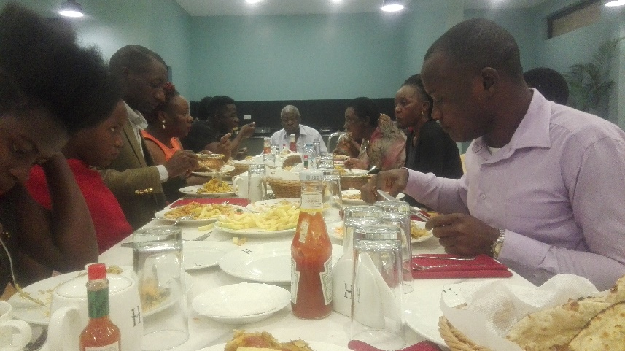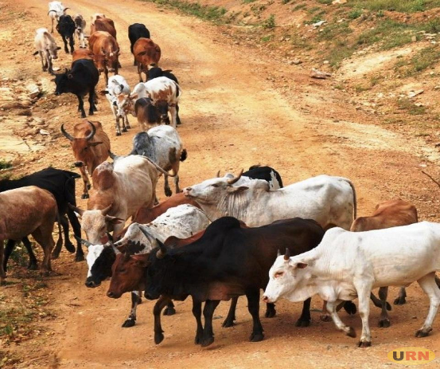

Below are the formulae of the substances mentioned in the above passage.

|  |  |
| --- | --- |
| substance | formula |
| water | H20 |
| glucose | C6H12O6 |
| Sodium chloride | NaCl |

**Task**

1. As a chemistry student, what do you think is the importance of water to humans and livestock?(4scores)
2. Assuming you are required to find out the relative atomic mass of each of the above substances, what would be the relative atomic mass of; (6 scores)
3. Water (H=1, O=16)
4. Glucose (C=12, H=1, O=16)
5. Sodium chloride, ( Na=23, Cl=35.5)
6. Calculate the percentage of oxygen in;
7. Water (2scores)
8. Glucose (3scores)

**Item 4.**

Air which is a mixture of different components contains 21% oxygen. Due to a wide spread of respiratory illnesses caused by COVID-19, there was an increased demand for oxygen by patients in hospitals. The government supply of oxygen is not enough and is planning to set up an oxygen production plant with minimal environmental impact.



However, the science club members in your school would like to know how the process of production will be carried out.

**Task:**

As chemistry student, make a write up you will use during the presentation

**Part II**

*Answer* **one** *item from this part*.

**Item 5.**

Natural resources have been destroyed as a result of increasing population and human activities. This has attracted the attention of the officials from the National Environment Management Authority (NEMA).



The officials are planning to create awareness to the people of the country through sensitization workshops organized in different district communities.

**Task:**

As a chemistry student, prepare a short presentation you will deliver during the workshop upon invitation.

**Item 6.**

Osukuru village in Tororo district is at the foot of Tororo rock. People of this village for a long time have practiced charcoal burning , animal husbandry , crop husbandry and stone quarrying, recently the animals have started dying and wells are drying up yet the little water available is not fresh. The locals are now wondering why all these are happening.



A sensitization workshop is to be organized to explain the existing situation in the village. The theme of the work shop is **MY ENVIRONMENT MY RESPONSIBILITY**.

Task:

As chemistry student, write a massage you will deliver upon invitation.

**END**